**LAB ASSIGNMENT #5**

**STATEMENT:** WRITE A PROGRAM TO IMPLEMENT THE RECORDS OF STUDENTS’ ADMISSION USING STRUCTURE AND POINTER. INCLUDE:

* 1. ADD
  2. DELETE
  3. DISPLAY

**ALGORITHM:**

Step-1: Start

Step-2:

Step-3:

Step-4:

Step-5:

**SOURCE CODE:**

#include <stdio.h>

#include <conio.h>

#include <string.h>

#include <stdlib.h>

typedef struct

{

int id;

char name[10];

int fee;

}rec;

rec std, *ptr=&std, *temp;

int nor=0, i;

void add()

{

int n;

printf("\n How many records do you want to add? \n");

scanf("%d", &n);

for(i=0;i<n;i++)

{

printf("\n Enter the Information: \n");

printf("\n ID No.: ");

scanf("%d",&(ptr+i)->id);

fflush(stdin);

printf("\n Name: ");

scanf("%s",(ptr+i)->name);

fflush(stdin);

printf("\n Fee: ");

scanf("%d",&(ptr+i)->fee);

nor++;

}

}

void del()

{

int did, i, alt;

printf("\n Enter ID no. to delete: ");

scanf("%d",&did);

for(i=0, alt=0;i<nor;i++, alt++)

{

if((ptr+alt)->id==did)

{

alt--; nor--;

printf(".........Record deleted........");

}

else

{

(ptr+alt)->id=(ptr+i)->id;

strcpy((ptr+alt)->name,(ptr+i)->name);

(ptr+alt)->id=(ptr+i)->fee;

}

}

}

void modify()

{

int mid, i;

printf("\n Enter ID no. to modify: ");

scanf("%d",&mid);

for(i=0;i<nor;i++)

{

if((ptr+i)->id==mid)

{

printf("\n Enter the information");

printf("\n ID No.: ");

scanf("%d",&(ptr+i)->id);

fflush(stdin);

printf("\n Name: ");

scanf("%s",(ptr+i)->name);

fflush(stdin);

printf("\n Fee: ");

scanf("%d",&(ptr+i)->fee);

printf("\n.......... Record modified.........");

}

}

}

void main(void)

{

clrscr();

int choice;

while(1)

{

printf("\n Menu\n1) Add customer\n2) Delete\n3) Modify\n4) Exit");

printf("\n Enter your choice: ");

scanf("%d",&choice);

switch(choice)

{

case 1:

{

add();

break;

}

case 2:

{

del();

break;

}

case 3:

{

modify();

break;

}

case 4:

{

printf("\n You chose to exit, press any key to end . . .");

getch();

exit(1);

}

default:

{

printf("\n Wrong input. Press any key and please try again");

getch();

}

}

}

}

**OUTPUT:**

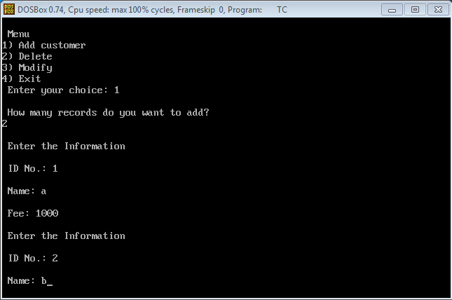

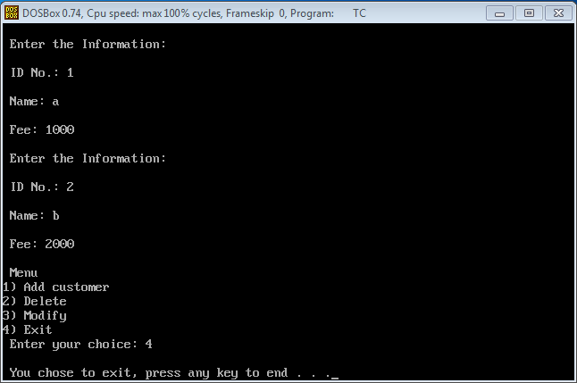

**CONCLUSION:** Hence, the program was successful, and the record of students’ admission was implemented using structure and pointer including; add, delete and display.